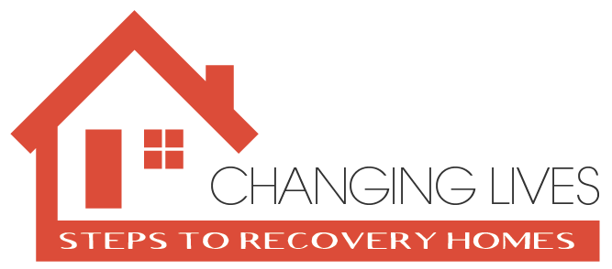
Organization or Business name_______________________________________________
Non – Profit yes _______ No ________
Address _________________________________________________________________
City _______________________ State ____________ Zip Code ___________________
Email Address ________________________________ Phone # ___________________
Would you like to be a sponsor for this event yes_________ No ___________
Would you like to sponsor upcoming events yes__________ No ___________
Would you like to be added to our newsletter yes_________ No____________

How will you be making payment ? Check ________ Credit Card _________ Cash _________
Ways to make payment:
Check: Mail it to 1120 Peaks View Dr. Clarkdale Az. 86324/ Payable to: Steps to Recovery Homes
Cash: Drop of Cash or Check at 541 N. Main St. Cottonwood Az. 86326 – Miracles Happen
Credit Card: Go to www.stepstorecoveryhomes.org /donate/ and put for exhibit in the memo

